# Microservice Transactional scenario with event driven architecture

1. DESCRIPTION
2. Start ZOOKEEPER
3. Start KAFKA
4. Start MongoDB
5. START LISTENER TO TOPIC
   1. confirmBookingTopic
   2. notConfirmBookingTopic
   3. pendingBookingTopic
6. project **01-batteryBookingInformation_SERVICE**
   1. DETAILS: TOPIC IMPLEMENTATION
   2. DETAILS: PROCESS DB INQUIRY
   3. DETAILS: POM
      1. spring-cloud-stream
      2. spring-cloud-starter-stream-kafka
      3. spring-boot-starter-data-mongodb
   4. RUN FROM .BAT
   5. LIST BOOKING INFOS

<http://localhost:7112//bookingInfoMaterializedView/list> NULL

1. project **01-batteryManagement_SERVICE**
   1. DETAILS: TOPIC IMPLEMENTATION
   2. DETAILS:
   3. RUN 01_**batteryManagement** _SERVICE
      1. Show log output
      2. Show database load
   4. Show topic subscriber **EMPTY**
   5. RUN FROM .BAT
2. project 01_bookAbattery_SERVICE
   1. DETAILS: TOPIC IMPLEMENTATION
   2. DETAILS: PROCESS DB INQUIRY
   3. DETAILS: POM
      1. spring-cloud-stream
      2. spring-cloud-starter-stream-kafka
   4. RUN 01_bookAbattery_SERVICE –profile localmysql FROM .BAT
      1. Show log output
      2. Show database load

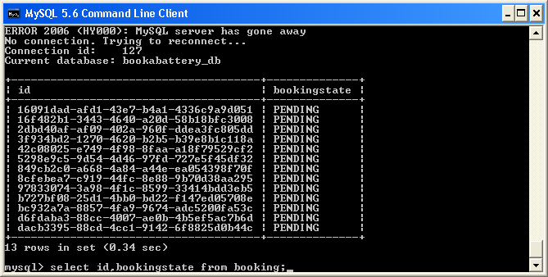

* + 1. Show log file with executing jobs

DbPollingPendingCleaner Job -> 09/06/2016 16:29:13

DbPollingPending Job -> 09/06/2016 16:29:13

DbPollingPending Job -> 09/06/2016 16:29:23

DbPollingPending Job -> 09/06/2016 16:29:33

DbPollingPendingCleaner Job -> 09/06/2016 16:29:38

DbPollingPending Job -> 09/06/2016 16:29:43

DbPollingPending Job -> 09/06/2016 16:29:53

DbPollingPending Job -> 09/06/2016 16:30:03

DbPollingPendingCleaner Job -> 09/06/2016 16:30:03

DbPollingPending Job -> 09/06/2016 16:30:13

DbPollingPending Job -> 09/06/2016 16:30:23

DbPollingPendingCleaner Job -> 09/06/2016 16:30:28

* + 1. Show Topic subscriber

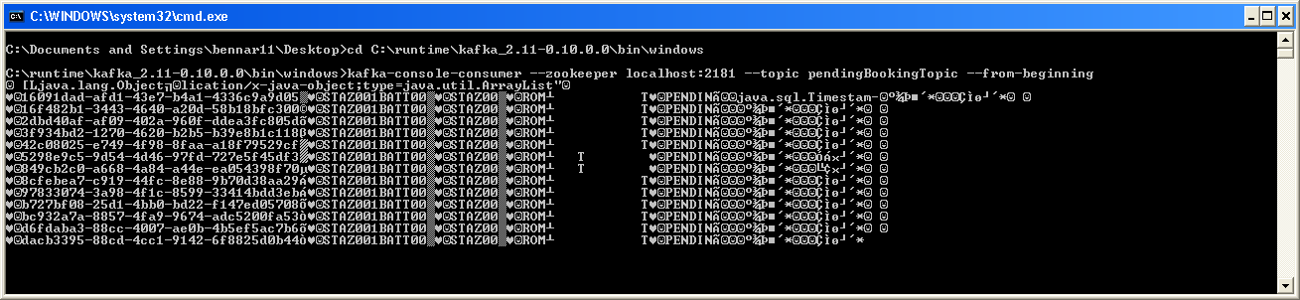

* + 1. Show database update

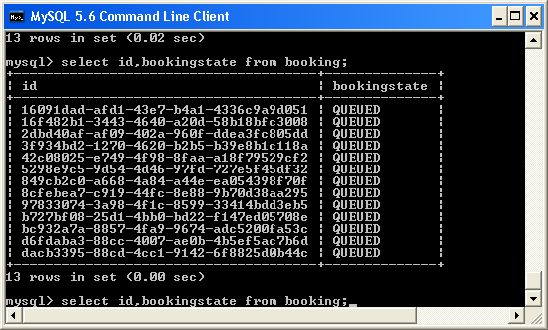

* + 1. Blah

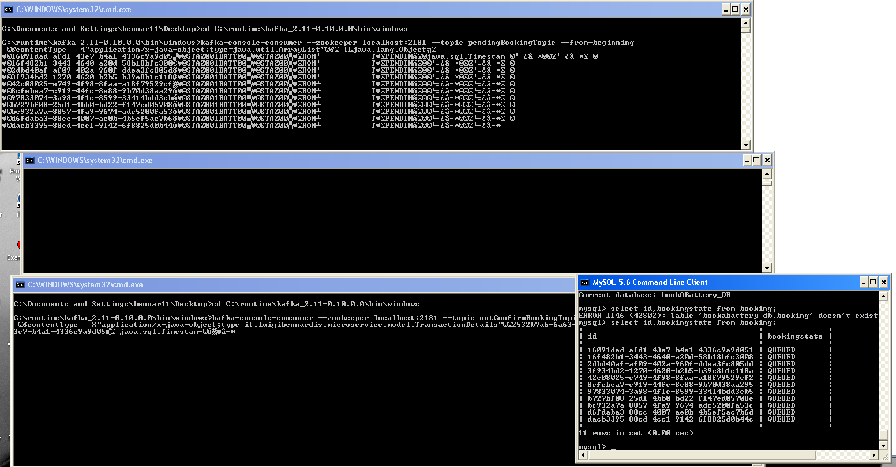

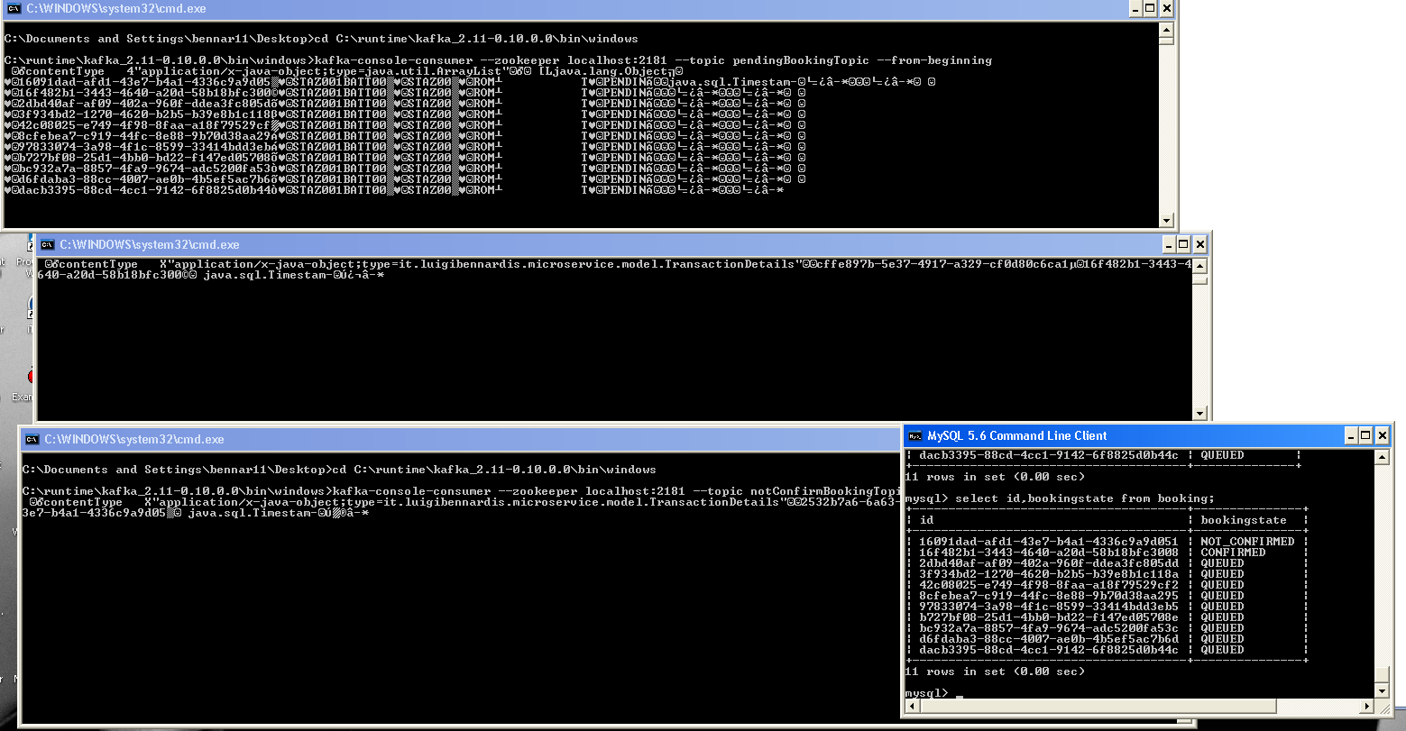

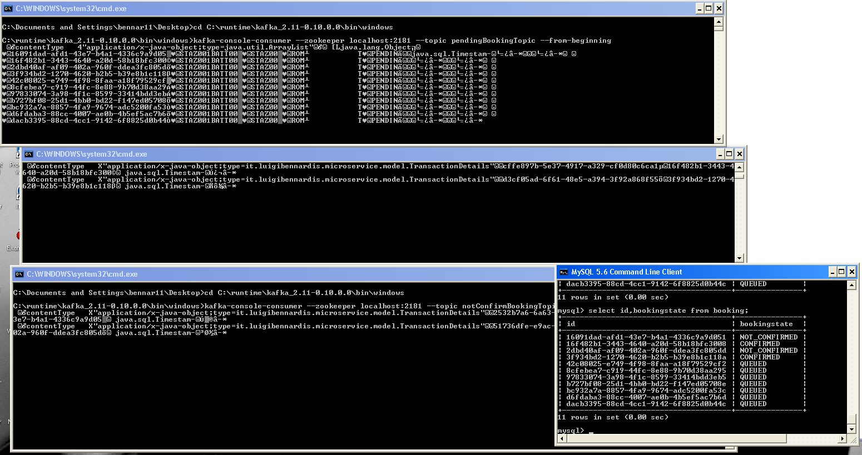

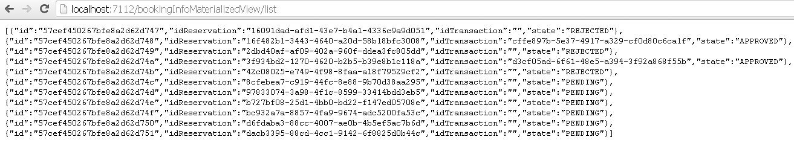

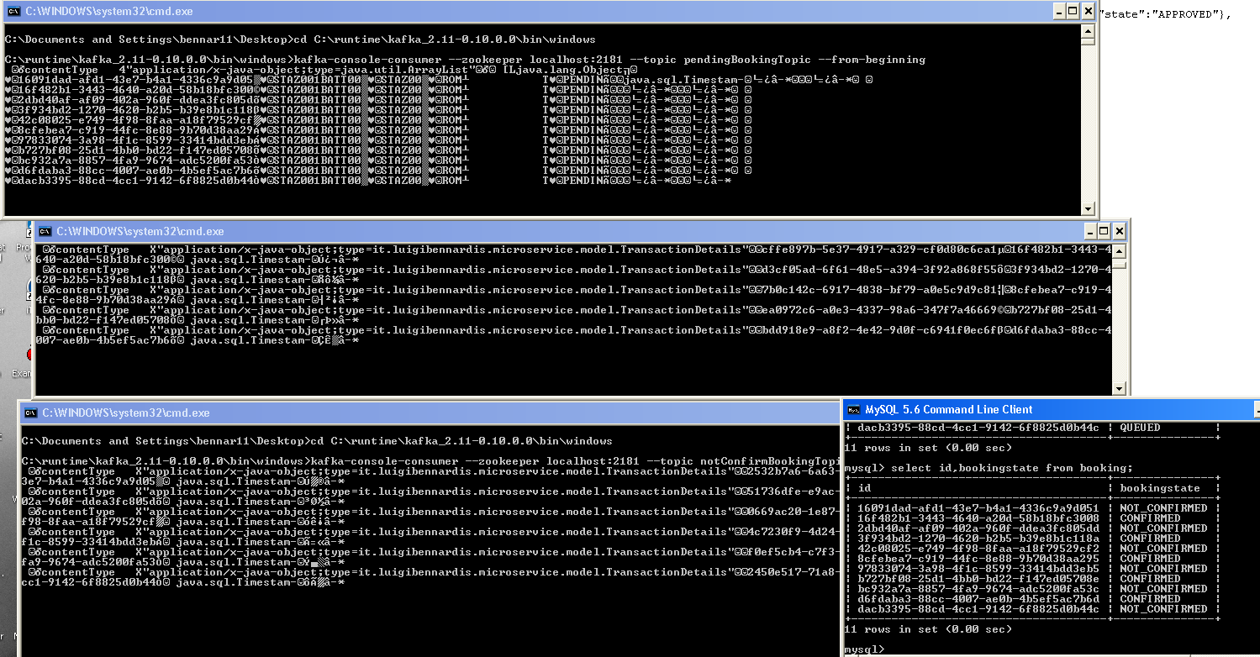

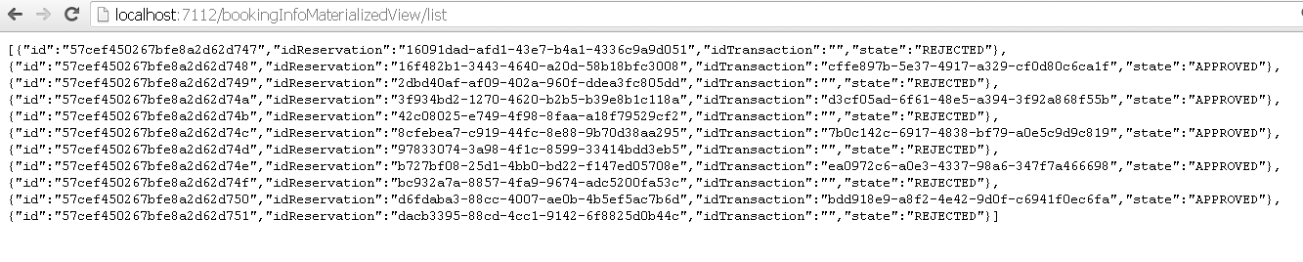

1. Stop core services and check information services still running